Synchronization

What is the synchronization?

* The capability to control the access of multiple threads to any shared resource.
* At a time will be executive one “Thread” and remaining threads is blocks.

Use of Synchronization?

We can use synchronizations is two ways.

1. Methods
2. Block

1.Methods

We can use synchronization key word in method statement is called ‘methods synchronization’.

Methods synchronizations is use both static and non static method.

Static method;-

Examples:-

Public static void add(){

}

Non Static method:-

Examples:-

Public static void add() {

}

2.Block:-

We can use synchronization key word before block is called ‘Block synchronization’.

Block synchronization is use both static and non static blocks.

Static block:-

Synchronization static {

}

Non static block:-

Synchronization { }

Thread Life Cycle:-

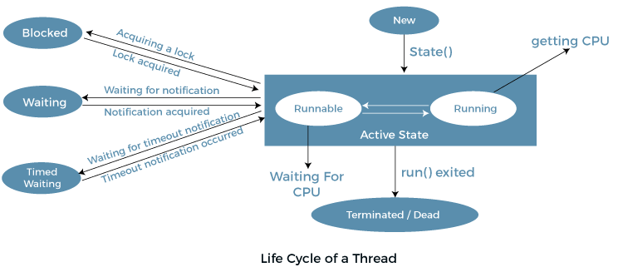

1. **New:** Whenever a new thread is created, it is always in the new state.
2. **Active:** When a thread invokes the start() method, it moves from the new state to the active state. The active state contains two states within it: one is **runnable** , and the other is **running**.

* **Runnable:** A thread,that is ready to run is then moved to the runnable state.

* **Running:** When the thread gets the CPU, it moves from the runnable to the running state.

1. **Blocked or Waiting:** Whenever a thread is inactive for a span of time (not permanently) then, either the thread is in the blocked state or is in the waiting state.
2. **Timed Waiting:** Sometimes, waiting for leads to starvation. The sleep() method puts the thread in the timed wait state.
3. **Terminated:** A terminated thread means the thread is no more in the system. In other words, the thread is dead, and there is no way one can respawn (active after kill) the dead thread.